**OUTREACH SCHOOLS EXAMINATION BOARD**

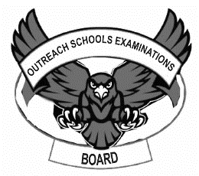**EKIGEZO EKITANDIKA OLUSOMA OLWO’KUSATU 2023**

**EKIBIINA EKISOOKA**

**LUGANDA**

**Erinnya lyange nze: ____________________________________________**

**Ekibiina: _______________________________________________________**

**Essomero: ____________________________________________________**

1. Erinnya lyange nze ___________________________________________
2. Ndi mukibiina ________________________________________________
3. Nsomera ku _________________________________________________
4. Nina amaaso ________________________________________________

**(musanvu , etaano, kyakusatu, ekisooka, mukaaga, kkumi)**

1. **Tuuma bino amannya.**

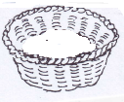

___________________ ___________________



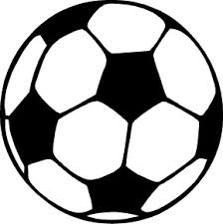

____________________ ___________________

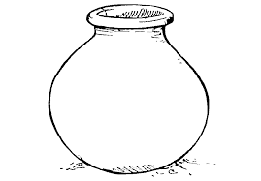

____________________

(ensuwa, omupiira, ekisero, ekkalaamu, eccupa)

1. **Jjuzamu enyingo ezibulamu**

mba mbe ______, ______,_________

______,_______, nki, nko,______

_____,______,nyo, nyu_______

sa ,se,_______,_______,_______.

1. Ennukuta emperezi ziri ___________________(kkumi ,ttaano)
2. **Kola akakubo kubigambo ebikontana.**

tunula ggalawo

tuula mukadde

muwala zibiriza

waggulu kikadde

ggulawo yimirira

kipya mulungi

muto wansi

mubi mulenzi

1. **Saza ku kituufu.**

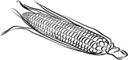

kasoli kasooli likaaso sookali

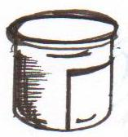

omukbee omuekbe omukebe

D:\Local Disk F\New folder\KIBUUKA 2023\pictures\kibuuka pic\BOTTLE.jpg

cuppa ccupa cupac

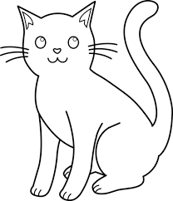

kaapa kappa kkapa

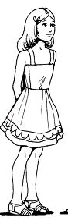

omuwala omwuala omuwlaa

1. **Maliriza emboozi zino**

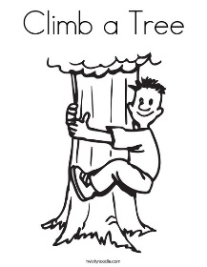

Samuel alinya ______________

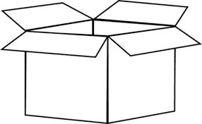

Kino ___________

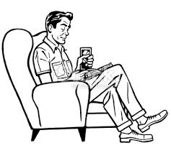

Ali atudde ku ____________

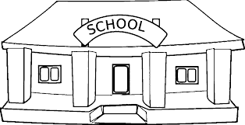

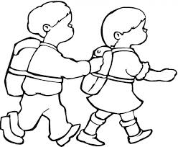

Abaana bagenda ku _________

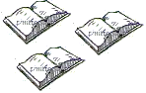

Bino ____________________

D:\Local Disk F\New folder\PRETTIE FOLDER\2020\PICS\PICS 1\am cooking food.tif

Maama afumba _______________



Ebimuli biri mu _____________

**(kibokisi, emmere, ssomero, ntebe, omuti, bitabo, mukebe)**

1. **Wandiika omuwendo.**

Mukaaga __________ musanvu_____________

ssatu _____________ bbiri _____________

ttaano ____________ emu ________________

kkumi ____________ mwenda ____________

1. **kola ebigambo**

ka - jjo

ko - ko

bi ka - lu

too-mi

bi

1. ____________________________
2. ____________________________
3. _____________________________
4. _____________________________
5. _______________________________

**\*Bikomye Awo\***